**Agenda :**

* Time Series
* Importance of Time Series
* Smoothing Methods
* Project on Time Series with Airlines dataset
* ARIMA Model

**Time Series :**

1. It is an sequence of values of a variable at equal spaced time internal .
2. It is a series of datapoints ordered in time .
3. Time series analysis is a statistical technique that deals with time series data ,or trend aalysis.Time series data means that data is in a series of particular periods or intervals.
4. We refer today as T ,yesterday as T-1 day before yesterday as T-2 and henceforth .And T+1 for tomorrow and so on .
5. The data is considered in 3 types:
   1. Time series data : A set of observation on the values that a variable take different times .
   2. Cross-Sectional data: Data of one or more variables, collected at the same point in tie
   3. Pooled data: A combination of time series data and cross-sectional data .
6. We dont take in consideration seasonal data or stats in time series .
7. We drop trends also in time series because it get vulnerabilities .
8. After dropping these factors we can do time series forecasting .
9. We can have different types of time interval .
10. Here have only 2 variable time and value.

**Importance of Time Series :**

1. Time series is very important to solve a lot of problems in the business.
2. Based on time we create a lot of data .
3. We can use this to predict future operations.

**Application :**

* 1. Economic Forecasting
  2. Sales Forecasting
  3. Budget analysis
  4. Stock market analysis
  5. Inventory studies etc

**Time series components:**

1. It can be described in terms of 4 basic classes of components:
   1. **Trend** : It is a long term direction of a time series .It exist in long term increase or decrease in the [data. It](http://data.it/) does not have to be linear, sometimes we will refer to a trend “changing direction”, when it might go from an increasing trend to a decreasing trend.
   2. **Seasonal** : It is a regular pattern of variability within certain time periods such as year.
   3. **Cyclical**: Any regular pattern of sequences of values above and below the trend.
   4. **Irregular**: Cannot be defined it can change without a pattern.

**Stationarity :**

### Rule for TimeSeries Data

- Data should be stationary..

- By nature no data has stationary format, We have to convert the data into stationary data then we can apply TimeSeries techniques.

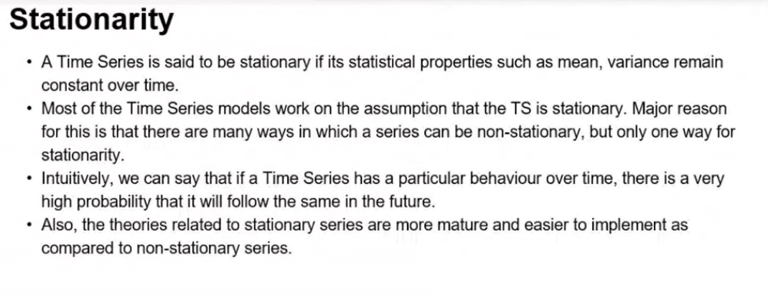

**Smoothing Methods:**

1. It removes the random variations and shows trend and cyclic components.
2. When a time series contains a large amount of noise, it can be difficult to visualize any underlying trend.
3. There are 2 methods.

**ARIMA Model:**

1. Auto Regressive (AR) Integrated(I) Moving Average (MA)

**ACF &PACF :**

1. Auto Correlation Factor and Partial Auto Correlation Factor